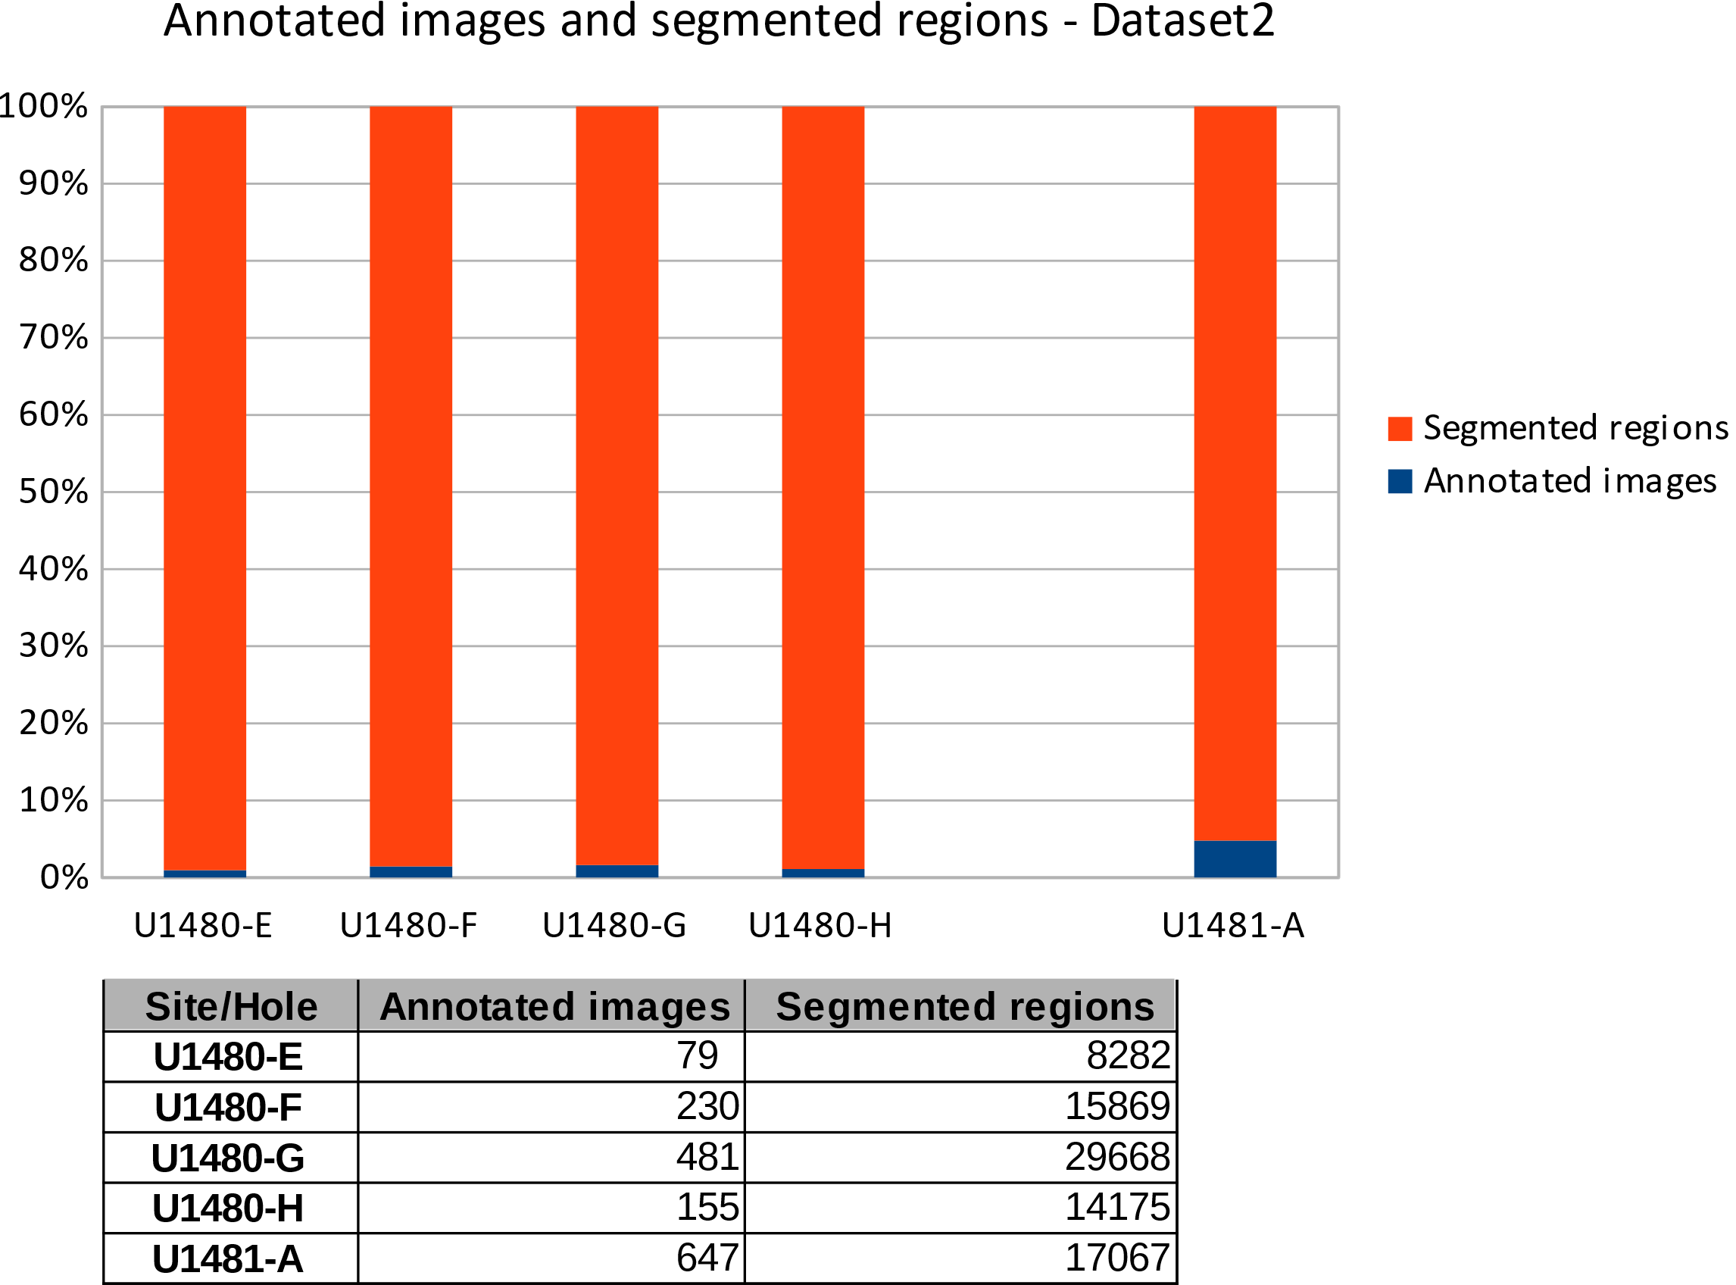

Figure 1 Summary of the formation of dataset2 between annotated images and segmented regions. Site/Hole covers sites U1480 and U1481 in the defined range.